MENTAL HEALTH DATA ANALYSIS REPORT
An Analytical Study on Global Mental Health Trends and Influencing Factors

Submitted in partial fulfillment of the requirements

For the award of the degree of

BACHELOR OF TECHNOLOGY
IN
COMPUTER SCIENCE AND ENGINEERING (ARTIFICIAL INTELLIGENCE AND DATA SCIENCE)
Submitted by
Aastha Sehgal (Roll No. 2823852)
Utsav Chopra (Roll No. 2823890)
Ansh Bajaj (Roll No. 2823874)
Ekansh (Roll No. 2823805)
Under the supervision of
Mr. Hansraj Singh

Panipat Institute of Engineering & Technology,

(Affiliated to Kurukshetra University Kurukshetra, India)
Samalkha, Panipat
(Session 2023-27)

CANDIDATE’S DECLARATION

I hereby declare that the work presented in this training report entitled “Mental Health Analysis”, submitted in partial fulfillment of the requirement for the award of the degree of Bachelor of Technology in Btech CSE(AI&DS), submitted to Panipat Institute of Engineering & Technology, Kurukshetra University, Kurukshetra, India is an authentic record of our teamwork carried out during the period from 10/06/2025 to 7/07/2025.

Date: 7/07/2025
Place: Panipat Institute of Engineering & Technology

Acknowledgement

We would like to express my sincere gratitude to all those who have supported and guided me throughout our internship experience.

First and foremost, I would like to extend my heartfelt thanks to our internship supervisor, Mr. Hansraj Singh, Data Science Consultant / Instructor @TransOrg Analytics @Pickl.AI, for their invaluable guidance, constant support, and constructive feedback during the entire internship period. Their expertise and encouragement played a key role in my learning and growth.

We are also thankful to TransOrg by Pickle AI for providing us with the opportunity to work on a meaningful and impactful problem statement. The resources, learning environment, and practical exposure offered through this collaboration significantly enriched our learning experience.

Lastly, I would like to acknowledge the support of my faculty members and peers for their valuable suggestions, encouragement, and collaboration throughout this journey.
This project has been a rewarding and enriching experience, and I am truly grateful to everyone who contributed to its successful completion.
Thank you.

CHAPTER 1: INTRODUCTION TO MENTAL HEALTH
In recent years, mental health has gained unprecedented attention on a global scale, emerging as a critical area of concern across healthcare, academia, and policy-making domains. Mental health encompasses an individual’s emotional, psychological, and social well-being, influencing how people think, feel, and act. It also determines how individuals handle stress, relate to others, and make choices.
The growing recognition of mental health stems from an alarming increase in the prevalence of disorders such as depression, anxiety, and stress-related conditions particularly among adolescents and young adults. According to the World Health Organization (WHO), one in eight people globally lives with a mental disorder, highlighting the urgent need for proactive strategies, awareness, and effective interventions.

Why study mental health?
Mental health is an essential part of overall well-being, shaping how individuals think, feel, and interact with the world around them. It influences daily functioning, decision-making, relationships, academic performance, and work productivity. With rising cases of anxiety, depression, and stress — especially among youth — mental health has become a global public health priority that can no longer be ignored.
Studying mental health helps us understand the root causes of emotional distress and identify patterns across different social and economic groups. This knowledge enables early detection, informed intervention, and effective support systems. It also helps reduce the stigma associated with mental health conditions and encourages more people to seek help when needed.
By analyzing mental health through data-driven research, we can design better healthcare policies, promote emotional resilience, and create inclusive environments in schools, workplaces, and communities. Ultimately, investing in mental health is an investment in a healthier, more productive, and more empathetic society.

Wellcome conducted the first Global Monitor, the largest-ever study of public attitudes to science and health in 2018. The first wave covered topics such as whether people trust science, scientists and information about health, and attitudes towards the safety and efficacy of vaccines, a focus which has since proved to be incredibly forward-thinking.
In 2020, a central focus of the Global Monitor was the role of science in mental health.
In 2020, Welcome launched its commitment to prioritize funding science that would help address mental health problems, with an initial focus on anxiety and depression in youth, to advance its vision of a world in which no one is held back by mental health problems.
By focusing on mental health specifically, anxiety and depression as part of the 2020 Wellcome Global Monitor report, Welcome is seeking to help illuminate how the world views mental health science and to share insights into what scientists need to prioritize globally if new solutions are to be found.
Importantly, world views on health, mental health and science were in flux when the data were collected due to the pandemic. It is impossible to say how much or in what ways COVID-19 may have impacted the results, given that 2020 was the first time mental health-related questions were asked as part of the Global
Finally, the mental health questions on which this report is based were not the only questions included in the 2020 Global Monitor. Additional question sets in the survey update results from the 2018 Monitor on public views of science and health, including opinions about trust in the scientific and healthcare communities.
The 2020 Monitor also included several questions on public perceptions of climate change and the COVID-19 pandemic, which will be explored in a future report.
We hope the 2020 Welcome Global Monitor provides some interesting insights and sparks new conversations. The data are freely available, and we encourage people to explore them and hypothesis as they see fit.

CHAPTER 2: GOAL OF THIS PROJECT
This project explores the relationship between mental health and socioeconomic factors such as income, education, employment, age, and gender using a large-scale, multi-country survey dataset. Through exploratory data analysis (EDA), the aim is to uncover patterns and disparities that could help understand how different demographic groups experience mental health challenges across various regions. To analyse the impact of demographic, scientific trust, and socio-economic factors on an individual's mental health status, and to build a machine learning model that predicts whether a person is likely to experience mental health issues.

Data Collection
The dataset used in this project was obtained from a large-scale international mental health survey, inspired by the 2020 Wellcome Global Monitor. This survey was one of the most comprehensive efforts to understand public attitudes toward mental health, science, and healthcare across different countries.
Source of Data
The data includes responses from over 20,000 participants across multiple countries. It was collected through structured questionnaires distributed online and through partner institutions, ensuring a diverse and representative sample. The dataset is publicly available and ethically sourced for research purposes.
Data Cleaning
In this project, our mental health survey dataset has areas needing attention. The "cleaning" process can be carried out using the following steps:
Identifying Unhelpful Patterns:
Examine your thoughts, emotions, and behaviors to identify recurring negative patterns or triggers using self-reflection or journaling (analogous to .isnull().sum() to identify missing values).
Imputing Healthier Responses:
For core emotional needs or recurring negative thoughts: Fill these "missing values" with positive affirmations, self-compassion practices, or seeking support from a therapist or counselor (analogous to using median values with .fillna() for "Weight" and "Height" columns).
For specific triggers or unhealthy habits: Replace these with constructive coping mechanisms or alternative behaviors (analogous to filling "Offsides" with 0 using .fillna(0)).
Dropping Unnecessary "Columns":
Remove activities, relationships, or commitments that consistently drain your energy or do not contribute positively to your mental well-being (analogous to removing the "Update Time" column using drop() function.

- Figure 1:Handling Missing Values
Feature Engineering
To extract deeper insights from the mental health dataset, we performed feature engineering to transform raw data into more meaningful features. This process helped in identifying important trends and patterns for exploratory analysis and model building.
One of the key engineered features was “Age_First_AnxDep”, which represents the age at which an individual first experienced anxiety or depression. This field was cleaned by removing null values and used to calculate metrics like minimum, maximum, and average onset age globally and across countries.
We also categorized continuous numerical features into bins for better visual interpretation:
- Age Groups (e.g., 18–25, 26–35, etc.)
- Income Levels (Low, Medium, High)
- Social Media Usage Frequency was grouped into low, moderate, and high engagement categories.
Additionally, we derived new features such as:
- Mental Health Support Level based on whether individuals sought professional help or relied on family/friends.
- Coping Strategy Effectiveness, by comparing the frequency and helpfulness of coping mechanisms.

1. Cleaning and Standardizing Raw Features
Before engineering new features, existing columns were cleaned by handling missing values, standardizing column names, and converting data types where .dropna() to remove null entries before calculating global and country-wise statistics. This column served necessary. For instance, the column Age_First_AnxDep was cleaned using as a foundation for deeper age-based analysis.

2. Age-Based Features
- Age Grouping: The continuous Age and Age_First_AnxDep values were converted into categorical bins (e.g., 15–24, 25–34, 35–50, 50+) using pd.cut(). This made it easier to visualize and analyze mental health trends across age brackets.
- Age at Onset Analysis: We calculated minimum, maximum, and average age of first experiencing anxiety or depression, both globally and per country, to understand early onset risks and regional mental health disparities.

3. Socio-Economic Groupings
- Income Levels: The Per_capita_income column was transformed into categories such as "Low", "Medium", and "High" using percentile-based binning. This allowed us to explore how economic status affects self-reported mental health.
- Education Groups: Education levels were categorized (e.g., primary, secondary, higher education) to analyze awareness and accessibility of mental health support across educational backgrounds.
- Employment Status was encoded to assess correlations between unemployment and mental health issues.

4. Coping and Support System Features
- Coping Mechanism Effectiveness: A new feature was derived by comparing the Frequency_of_Coping_Mechanism_Use with Self-reported_Improvement. A ratio was computed to determine the perceived effectiveness of coping strategies.
- Support Network Strength: Based on responses about talking to professionals and friends/family, individuals were categorized into strong, moderate, or weak support networks.

5. Psychological Attitudes and Beliefs
- Trust in Science Score: Combined responses from questions such as Trust_in_science, Science_Helps_Treat_AnxDep, and Gov_Fund_MH_Research into a composite score to analyze the relationship between belief in science and mental health awareness.
- Science vs Religion Influence: Analyzed how decision-making is influenced by science vs. religion, and how that aligns with attitudes toward mental health treatment.

6. Behavioural Features
- Social Media Usage: Created new categorical features (e.g., low, medium, high) from raw SM_Usage_Freq data to explore the influence of social media behavior on mental health.
- Health Content Engagement: A boolean feature was created to check if users consumed health-related content on social media (HealthContent_on_SM), which could affect awareness and coping.

7. Target Variable Transformation
For the machine learning model, the Self_MH_Status (self-reported mental health status) column was encoded into a binary classification target (0 = no issues, 1 = reported mental health issues), making it suitable for logistic regression.

These feature engineering steps allowed for meaningful visualizations (such as boxplots, histograms, and heatmaps), improved interpretability, and enhanced model accuracy. The engineered features not only reflect raw behavioural and demographic data but also encapsulate psychological, cultural, and environmental dimensions of mental health.

Data Transformation
Data transformation is a vital step in preparing the dataset for analysis and machine learning. It involves converting data into formats that are compatible with analytical tools and models while ensuring consistency, accuracy, and interpretability.
1. Handling Missing Values
Several columns contained missing or incomplete data, especially in features like Age_First_AnxDep and Per_capita_income. These were handled using:
- Deletion: Rows with critical missing values were dropped using .dropna() to ensure the quality of statistical analysis.
- Imputation: For non-critical missing data, values were imputed using mean or mode, depending on the column type.
2. Encoding Categorical Variables
Most machine learning models require numerical input. To transform categorical variables:
- Label Encoding was applied to ordinal features (e.g., education level).
- One-Hot Encoding was used for nominal variables like country, gender, or coping mechanisms, creating binary columns for each category.
3. Normalization and Scaling
To ensure that features like age and income didn’t dominate the model due to their large value ranges, we applied:
- Min-Max Scaling to normalize continuous features between 0 and 1.
- Standardization (Z-score scaling) for models sensitive to feature distributions.
4. Text to Numeric Transformation
For responses such as “Yes”, “No”, “Prefer not to say”, or “Don’t know”:
- They were mapped to numerical equivalents (e.g., Yes = 1, No = 0) to make the data model-ready.
5. Date Transformation
Any columns containing date values (e.g., survey completion dates) were converted to datetime format using pd.to_datetime() and were used to extract features like year, month, or time since the pandemic began.
6. Binning and Grouping
Continuous variables such as Age and Per_capita_income were grouped into categorical bins (e.g., Age Groups: 18–25, 26–35, etc.) to simplify visualizations and classification tasks.
7. Feature Reduction
To avoid multicollinearity and reduce dimensionality:
- Correlation heatmaps were used to identify highly correlated features.
- Redundant or low-variance columns were dropped to streamline the dataset.

These transformations made the dataset cleaner, more consistent, and better suited for downstream tasks such as exploratory analysis, model training, and visualization.

CHAPTER 3: EXPLORATORY DATA ANALYSIS
Exploratory Data Analysis (EDA) is an essential process for understanding the structure, patterns, and relationships within a dataset. Before diving into modelling techniques, it is crucial to comprehend the dataset's characteristics through a variety of methods, including summary statistics and visual exploration.
Dataset Description is basically the information of the dataset that we can infer just after importing the dataset. It includes columns description, shape of the dataset, etc.
In this project, the dataset MENTAL HEALTH SURVEY data across different countries of the world. The deeper understanding of the data, the dataset description is:
Dataset Description
- COUNTRYNEW
- FIELD_DATE
- YEAR_WAVE
- Knowledge_about_Science
- Trust_in_science
- Tech_Impact_Local_Jobs_5Yrs
- Health_Impact_of_ScienceA
- Science_Explain_Emotions
- WHO based decisions
- Doctors Based Decisions
- Religion_Sci_Based_Decisions
- Importance of Mental Health
- Science_Helps_Treat_AnxDep
- Gov_Fund_MH_Research
- Communication_about MH
- Friends_Family MH_Issues
- Self_ MH_Status
- Age_First_AnxDep
- Repeated_Experience
- Talked_MH_Professional
- Helpfulness MH_Professional
- Medication_helpfullness
- Used_Social_Media
- SM_Usage_Freq
- HealthContent_on_SM
- Science vs Religion Belief
- Age
- Gender
- Education
- Per capita income
- wbi
- Income_Satisfaction
- Here the columns:
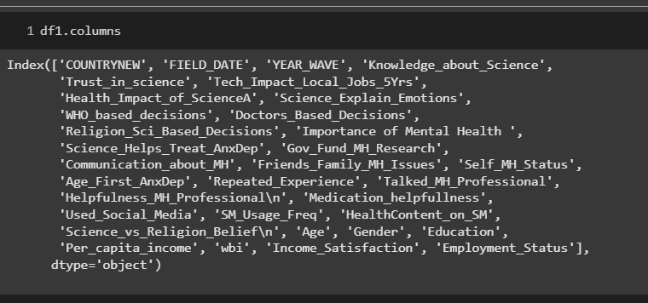

Size/Shape of the Dataset:
- The size or shape of the dataset is (20847, 33). I was calculated using the .shape function.
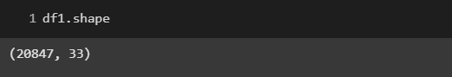

CHAPTER 4: STATISTICAL ANALYSIS
A statistical summary provides a quantitative overview of the dataset, helping to identify trends, outliers, and the overall structure of the data. It forms the basis for understanding the behaviour of key variables and supports the selection of appropriate data processing and modeling techniques.
1. Descriptive Statistics
Using the .describe() function in Python, we generated the following statistical measures for all numerical columns:
- Count: Number of non-null observations
- Mean: Average value of the feature
- Standard Deviation (std): Measure of variation or dispersion
- Min/Max: Minimum and maximum values
- 25%, 50%, 75% Percentiles: Values that divide the data into quartiles
For example, in the Age_First_AnxDep column:
- The mean age when participants first experienced anxiety or depression was approximately 22 years.
- The minimum recorded age was around 5 years, while the maximum was 65+.
- The standard deviation indicated significant variation across individuals and regions.
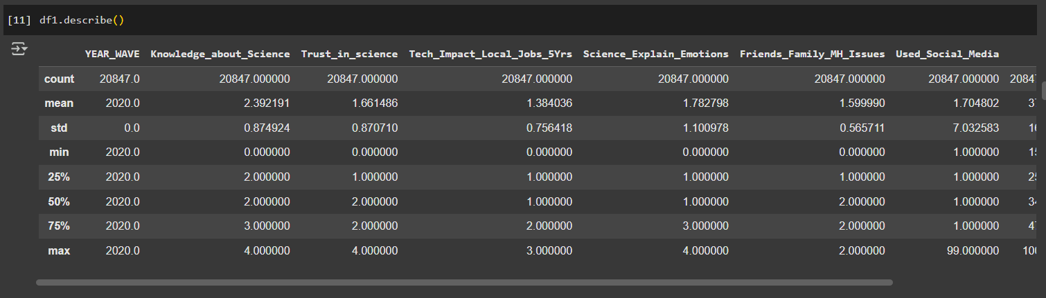
2. Categorical Variable Summary
For categorical variables like Gender, Country, Self_MH_Status, and Coping_Mechanism, we used:
- Value Counts to identify the most common categories
- Mode to determine the most frequent responses
- Proportional Distribution to observe representation across groups (e.g., % of participants reporting mental health issues)

3. Mental Health Status Overview
From the self-reported mental health status:
- Around 48% of respondents reported experiencing mental health challenges.
- The distribution varied significantly by age group, income, and region, hinting at socio-economic patterns worth deeper exploration.

4. Correlation Analysis
A correlation matrix was generated to examine relationships between numerical features such as:
- Age, income, trust in science, and mental health status
- Features with strong or moderate correlations were considered for further predictive modelling.

This statistical summary revealed important patterns and provided a foundation for the subsequent stages of exploratory data analysis and machine learning.
Visualizations
Visualizations or simply put, plots, are made using libraries like seaborn and matplotlib which further aid in deep understanding and gaining insights about the dataset. There are various types of visualizations such as bar plots, histograms, pie charts, box plots, violin plots, correlation maps (heatmaps), etc.
Distribution of Individual Age and Mental Health Conditions:
1. Geographical Distribution of Selected Survey Countries.
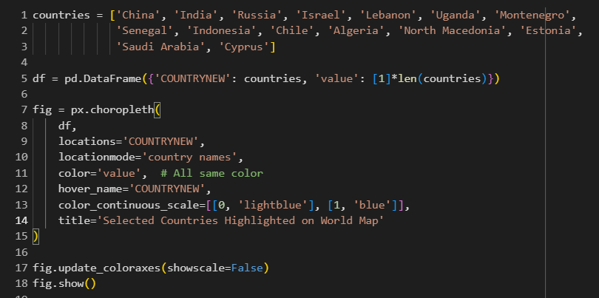
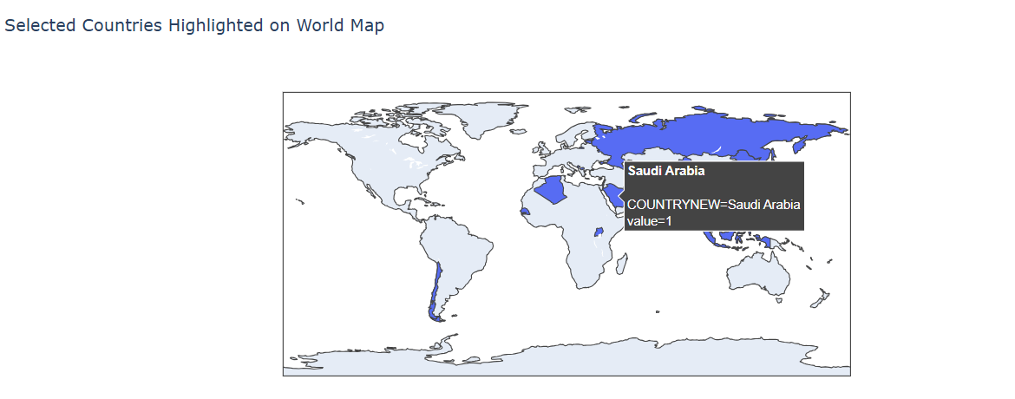
2. How does mental health status vary by country or region?
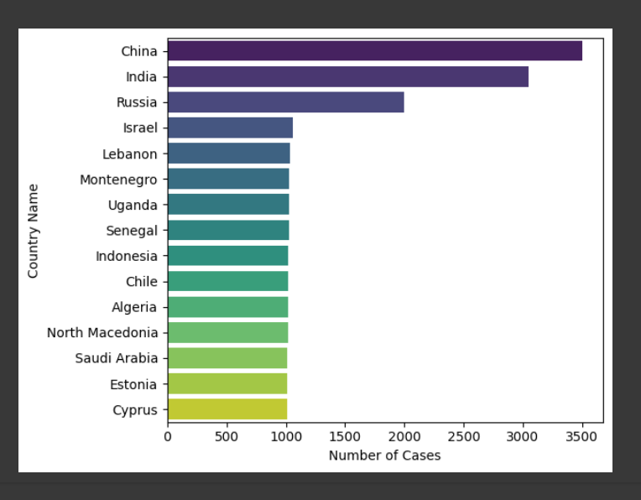
INTERPRETATIONS
- China and India report the highest number of mental health cases, which may reflect both their large population sizes and increasing awareness or willingness to report mental health issues.
- Variation across countries may be influenced by cultural, societal, or healthcare factors, with some countries possibly underreporting due to stigma or limited mental health infrastructure.
- Lower case numbers in countries like Cyprus and Estonia should not be misinterpreted as better mental health status, as these figures might be affected by sample size or survey participation rates.

3. What is the distribution of age when people first experienced anxiety or depression?
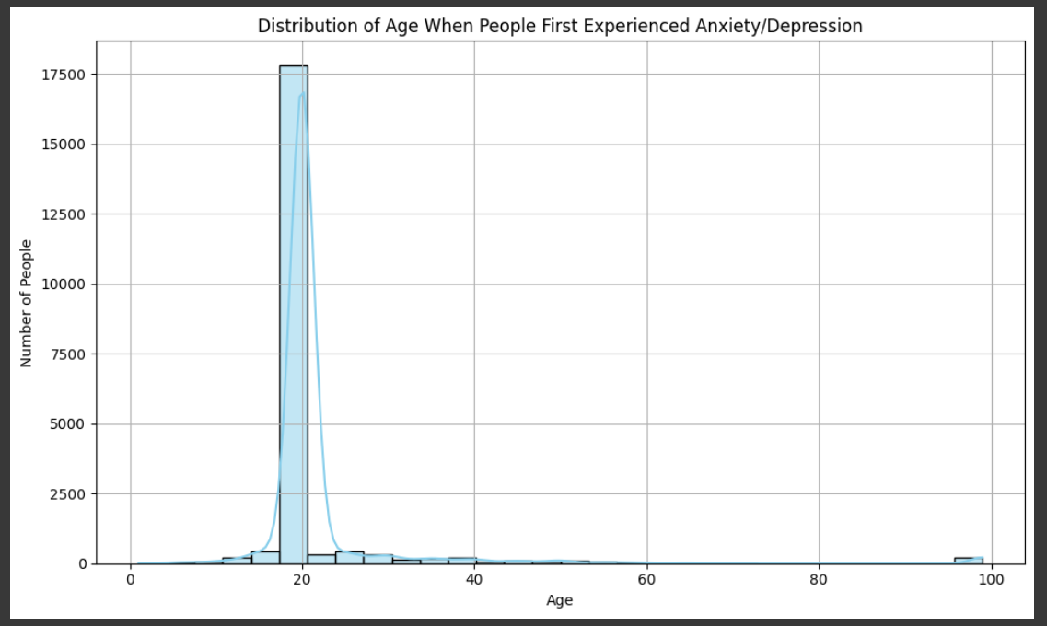
INTERPRETATIONS
- The peak is around 18–20 years old, with over 600 people in that bin.
- This suggests that late adolescence and early adulthood are the most common ages when people first report symptoms of anxiety or depression.
4.What is the age distribution of the respondents?
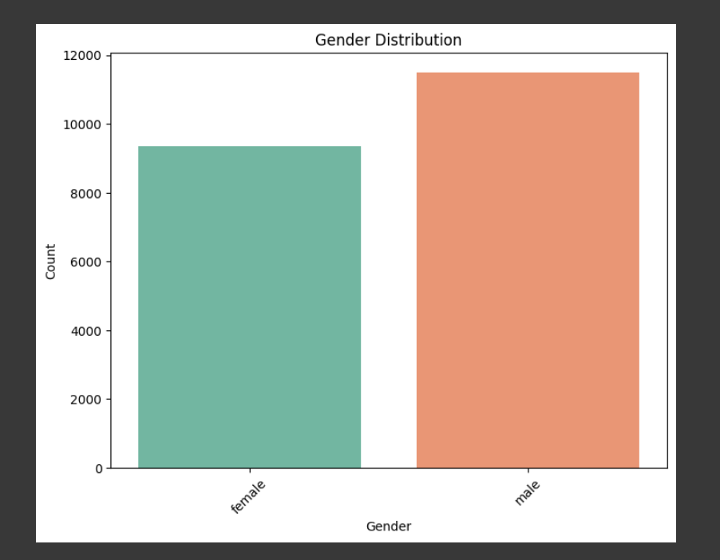
5. How is mental health status distributed across different age groups?
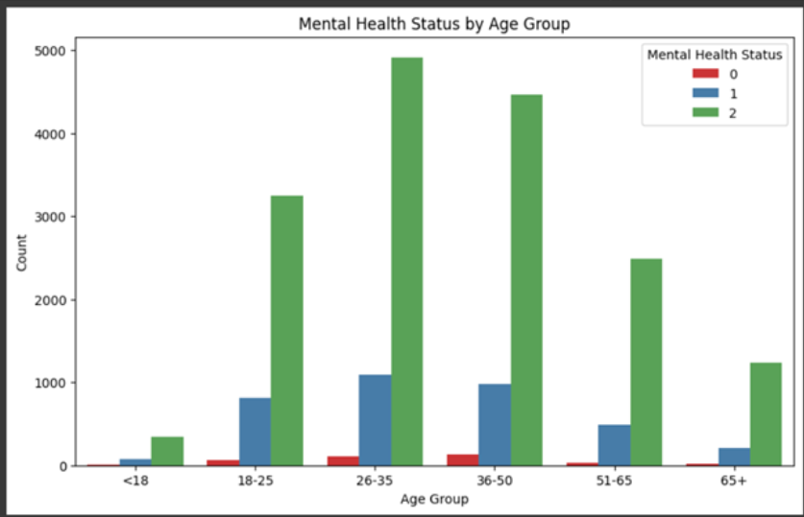
INTERPRETATIONS
1. The age group 26–35 shows the highest number of individuals reporting good mental health (Status = 2), followed closely by the 36–50 group, indicating stronger perceived mental well-being in early to mid-adulthood.
2. Younger (18–25) and older (65+) age groups report relatively fewer cases of good mental health, suggesting these populations may be more vulnerable or have less access to mental health support.

6. What is the relationship between trust in science and mental health status?
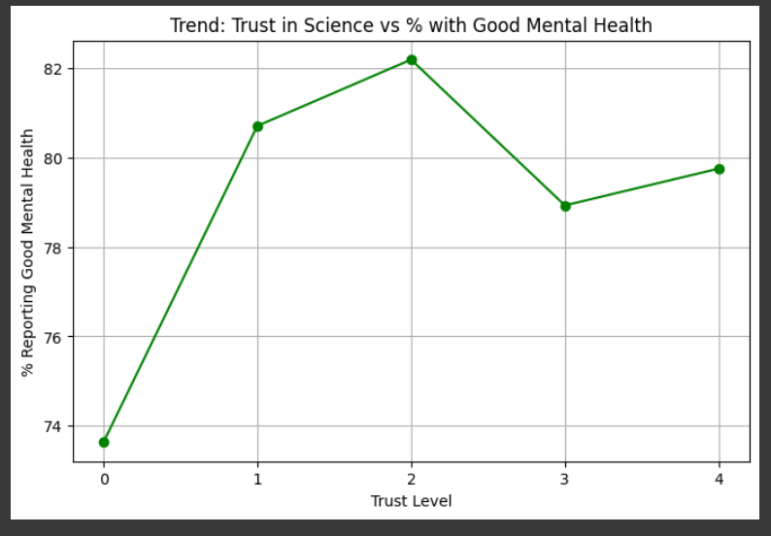
INTERPRETATIONS
- Higher trust in science (Trust Levels 1 and 2) is associated with the highest percentages of people reporting good mental health—over 80% in both cases suggesting a positive correlation between trust in science and mental well-being.
- The lowest percentage of good mental health (~74%) is observed among those who responded "Don't know" (Trust Level 0), indicating that uncertainty or lack of trust may relate to lower mental well-being.
- After peaking at Trust Level 2, the percentage of good mental health slightly declines at Levels 3 and 4, though it remains above the lowest levels—suggesting that extreme distrust might negatively impact mental health but not as sharply.

7. What is the co-relation between the numerical columns?
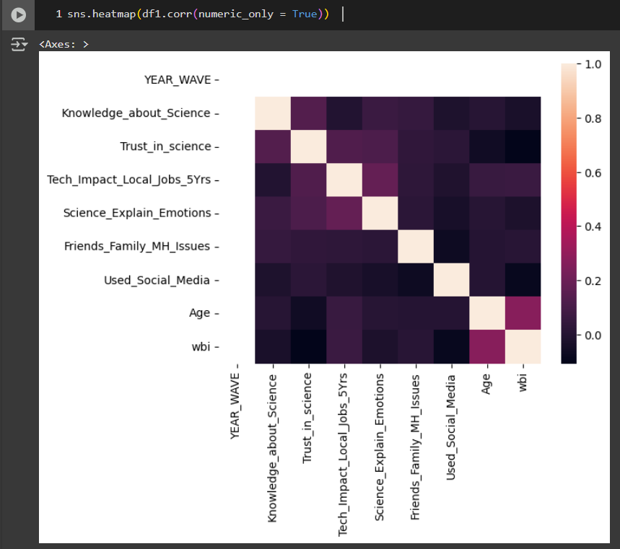

8. Are there patterns or commonalities in people reporting mental health issues?
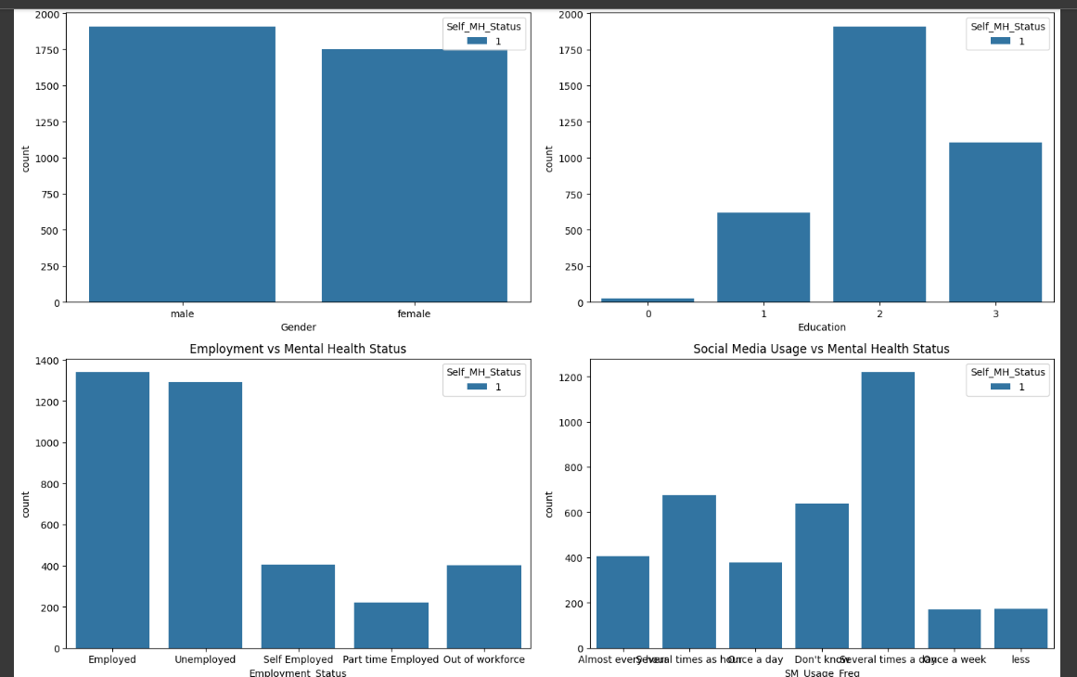
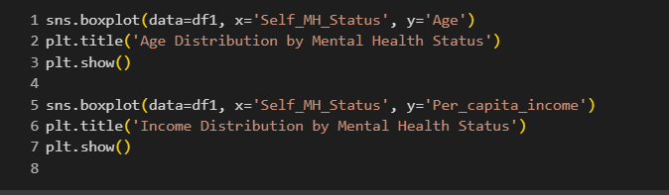

Age Trends Across Different Mental Health Status Groups:
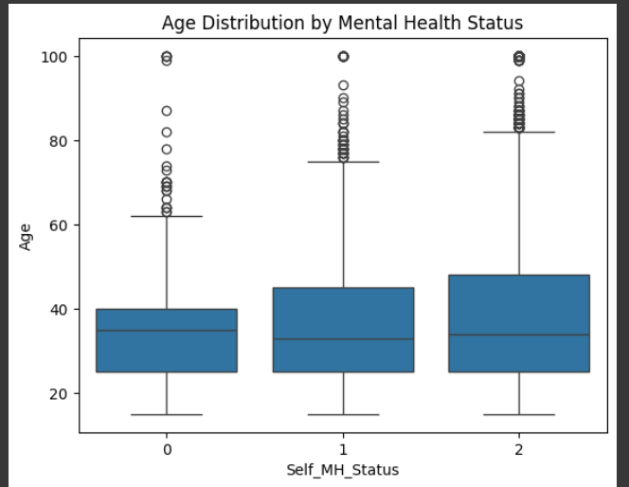

Outlier removal
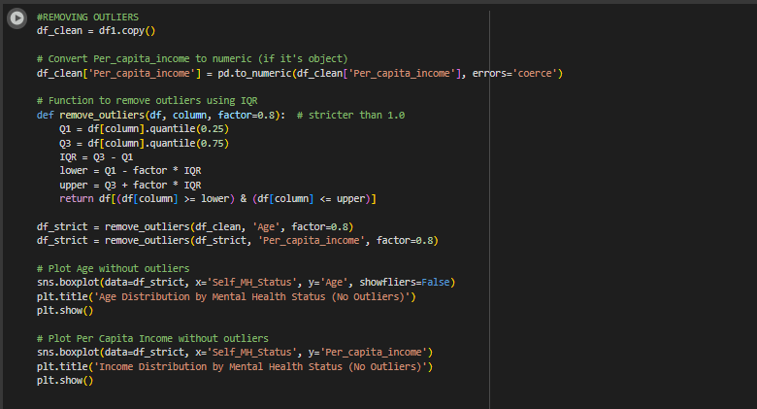
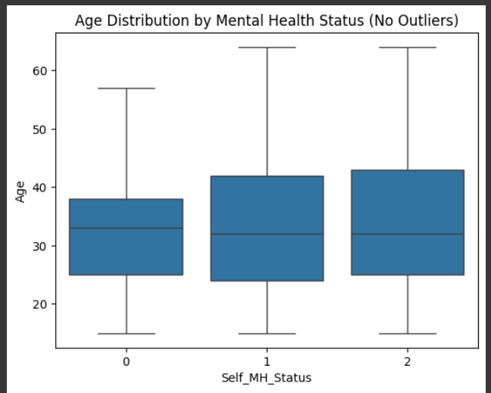

Overall interpretations
- Both males and females more likely to report mental health issues.
- People with moderate to high levels of education tend to report mental health issues more often.
- Unemployed individuals report mental health issues more frequently than those who are employed.
- Frequent users of social media (especially daily/multiple times a day) are more likely to report mental health issues.
- Higher age and lower income are commonly associated with mental health issues.
- Lack of awareness ("Don't Know") is more common in younger and middle-income individuals.
- These distributions support the idea that socio-economic and demographic factors like age and income significantly influence mental health self-reporting.

CHAPTER 5: PREDICTIVE MODELLING (LOGISTIC REGRESSION)
Predictive modelling using Logistic Regression is used to analyze and predict trends in mental health report making. Logistic modelling allows us to use past data to generate good forecasts about the likelihood of certain mental health outcomes. Through the use of logistic regression models, we strive to forecast metrics such as the probability of mental health issues by analyzing different patient attributes.
Model Selection (Logistic Regression)
Logistic regression is a statistical technique used to model the relationship between one dependent variable (e.g., presence of mental health issues) and one or more independent variables. The goal of logistic regression is to fit a logistic equation to the data that predicts the dependent variable from the independent variables.
Why Logistic Regression for this Dataset?
In this project, logistic regression is selected because it is perfect for predicting binary outcomes related to mental health, such as the presence or absence of conditions. It analyzes variables like stress levels, sleep hours, and therapy sessions on the basis of patient data such as age, gender, and lifestyle.

Logistic regression is a widely used machine learning (ML) algorithm designed for binary classification tasks. Unlike linear regression, which predicts continuous outcomes, logistic regression predicts the probability of a categorical outcome, such as whether a person suffers from an anxiety attack (yes or no). This makes it an ideal choice for mental health applications, where the goal is to classify individuals based on symptoms and risk factors.
How It Works?
Logistic regression models the relationship between a set of independent variables (e.g., stress levels, sleep duration, heart rate, age, and lifestyle factors) and a dependent variable (anxiety attack occurrence). It uses a logistic function, or sigmoid curve, to map predicted values to probabilities between 0 and 1. The model applies a threshold (typically 0.5) to classify the outcome: a probability above 0.5 indicates an anxiety attack, while below 0.5 suggests no attack.

1. Define Independent Variables (X) for Mental Health:
These would be factors you hypothesize influence mental health outcomes. Examples could include:
Sleep Quality: Hours of sleep, sleep latency, sleep efficiency.
Stress Levels: Perceived stress scale scores, frequency of stressful events.
Social Support: Number of close relationships, frequency of social interactions.
Physical Activity: Hours of exercise per week, type of activity.
Dietary Habits: Nutritional intake, frequency of healthy meals.
Coping Mechanisms: Use of positive or negative coping strategies.
2. Define a Dependent Variable (y) for Mental Health:
This would be the specific mental health outcome you want to predict. Examples could include:
Mental Well-being Score: Scores from validated mental health questionnaires (e.g., WHO-5 Well-being Index, PHQ-9 for depression, GAD-7 for anxiety).
Frequency of Symptoms: Number of days experiencing specific mental health symptoms.
Quality of Life Score: Self-reported quality of life measures related to mental health.
3. Data Collection and Model Training:
Similar to the original model, you would:
Collect Data:
Gather data for your chosen independent and dependent variables from a relevant population.
Split Dataset:
Divide your collected data into a feature matrix (X) and the target variable (y).
Train the Model:
Use a linear regression model to train on this data, aiming to understand the relationship between the chosen features and the mental health outcome.

4. Evaluate Results:
After training, you would evaluate the model's performance using metrics like:
R-Squared:
To understand how well the independent variables explain the variance in the dependent variable.
Mean Squared Error (MSE):
To quantify the average squared difference between the predicted and actual mental health outcomes.
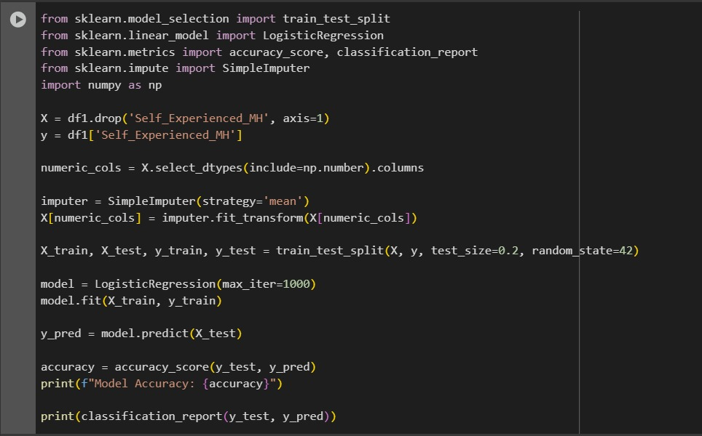

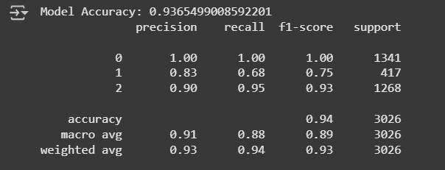

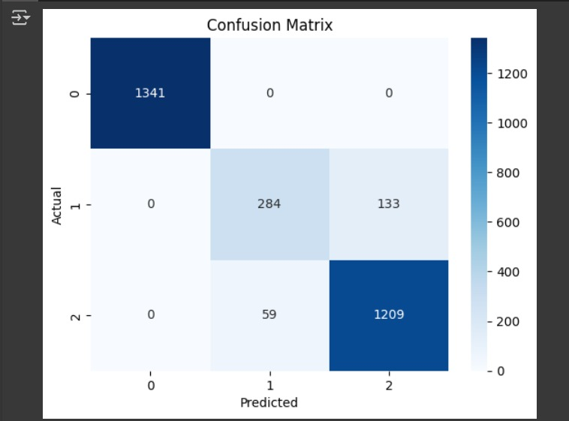
INTERPRETATIONS:
- The model performs very well for Class 0 and Class 2, with high accuracy.
- There is some confusion between Class 1 and Class 2, suggesting these two categories are harder to distinguish.
- No misclassification between Class 0 and the other two, indicating Class 0 is clearly separable.
Conclusion:
- Overall, the model shows strong performance, especially in predicting Class 0 and Class 2.
- Additional feature engineering or balancing may help improve prediction of Class 1.

CHAPTER 6: CONCLUSIONS AND FUTURE RECOMMENDATIONS

Mental Health's Rising Importance
The data showing that 92% of people worldwide believe mental health is as important or more important than physical health highlights a significant global shift in perspective. Historically, mental health has often been stigmatized and overlooked, but this statistic suggests a widespread, modern recognition of its fundamental role in overall well-being. This shift is crucial for advocating for more funding, research, and accessible care for mental health conditions.

The Public's Perception of Science
The contrast in how people view science's ability to help with infectious diseases (53%) versus anxiety and depression (31%) is a key finding. This suggests a disconnect between the public's awareness of mental health's importance and their confidence in science's ability to provide solutions.

For Infectious Diseases: People have seen and benefited from rapid scientific advancements, such as vaccines and antibiotics. These successes are tangible and have immediate, visible results, which builds public trust.

For Mental Health: Mental health conditions are often complex and multifaceted, with no single "cure" for many people. Treatments often involve a combination of therapy, medication, and lifestyle changes, and the results can be slower and less visible. This can lead to public skepticism about the effectiveness of scientific approaches.

The Need for a Diverse Approach
The fact that people globally use a combination of different approaches to manage their mental health underscores the complexity of these conditions. It's rare for one single treatment to be effective for everyone. People may use:

Evidence-based treatments: These include psychotherapy (like cognitive-behavioral therapy) and medication (like antidepressants).

Complementary and alternative therapies: This could include practices like mindfulness, yoga, meditation, or herbal remedies.

Social and cultural support: This involves leaning on family, community, and religious or spiritual practices.

The Wellcome Global Monitor's data suggests that the mental health science community needs to acknowledge and investigate this wide range of solutions, not just focus on a single type of treatment.

The Challenge for Mental Health Science
The final statement you provided acts as a call to action. Given the widespread recognition of mental health's importance and the public's skepticism about science's ability to help, the mental health science community must:
Build on what works: Continue to refine and improve existing evidence-based treatments.
Investigate all possible solutions: This means thoroughly researching not just traditional treatments but also a broader range of approaches that people are already using. This could help identify new, effective therapies and build public trust by demonstrating a willingness to explore all avenues.

Find next-generation treatments: The goal is to develop more effective, personalized, and accessible interventions that can address the diverse needs of people around the world.

